Homework Statement – English
Years 7-10
Homework will be set centrally for each year group on Teams every Monday. This will always be due in the first lesson of the following week.
Homework is divided into two parts:
- 30 minutes of Sparx Reader (online). Sparx Reader homework is designed to help students build strong reading habits through regular, careful reading practice. Each homework will consist of a target of 300 Sparx Reader Points (SRP) which students need to earn through careful reading. SRP are personalised to each student’s average reading speed with 10 SRP being roughly equivalent to 1 minute of careful reading. A target of 300 SRP equates to roughly 30 minutes of careful reading for all students in the class.
The amount of SRP a student earns after completing each check is based on:
- The amount of words in the section
- The student’s average reading speed
If a student continues reading after completing their weekly target, this extra SRP will back fill previous incomplete homework.
- The points will backfill the most recent homework first
- Student can backfill up to 6 previous homeworks
Books in Sparx Reader are broken into sections. At the end of each section they read, students will see a small number of questions or a ‘check’ to see how carefully they have read. If a student passes the check, they will earn some SRP. To pass the check, the student needs to answer the majority of the questions correctly. If a student has read carefully, the questions should be easy to answer correctly.
Sparx Reading Levels are a measure of student reading ability, on a 1 to 9 scale. These levels can be mapped to reading ages:
- Sparx Level 1-2: Reading Age 5-7 (Easier books to support struggling readers, and simpler tasks in place of questions)
- Sparx Level 3-4: Reading Age 9 -10 (Easier books to support struggling readers)
- Sparx Level 5-6: Reading Age 11-12 (Middle-grade books)
- Sparx Level 7-8: Reading Age 12-14 (Higher middle-grade books)
- Sparx Level 9+: Reading Age 15+ (Challenging books for stronger readers)
Students will be shown a selection of books that are appropriate for their Reading Level. Every time students do some reading or answer a question, Sparx Reader learns a bit more about how they read, and that all feeds into an estimate of their current reading level. The more students read using Sparx Reader, the more information Sparx will have to ensure their level is accurate.
In addition to reading, students have the option to do daily vocabulary practice in Sparx Reader.
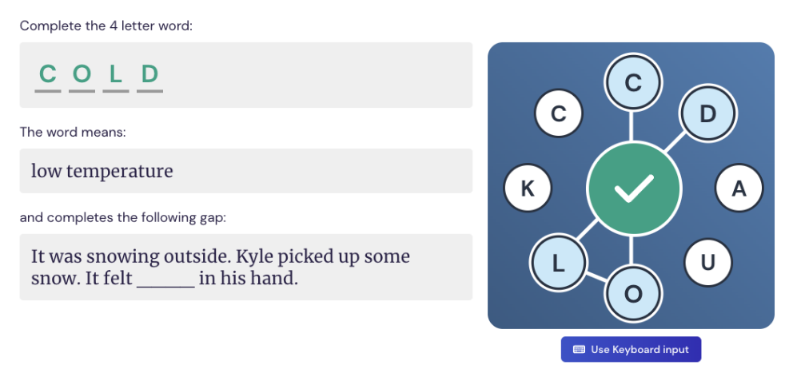

This activity is not compulsory, so students are not required to complete this as part of any homework, but each correct answer will earn 1 SRP.
- 30 minutes offline. In addition to completing 30 minutes of Sparx Reader homework, students will complete 30 minutes of offline homework. Tasks may include, although are not limited to:
- Pre-reading for the following lesson
- Reading to consolidate learning from the previous week
- Comprehension-style questions on a previously covered topic to strengthen long-term retention of knowledge
- Broadening understanding by applying existing knowledge in new contexts
- Reading beyond the specification to promote independent thinking and academic confidence
- Practising exam skills
All homework assignments will include an extension task. This is compulsory for all students in Band 1, but all students are encouraged to complete this.
Year 11
Homework will be set centrally for each year group on Teams every Monday. This will always be due in the first lesson of the following week.
Homework tasks will be offline. Tasks should take around 60 minutes to complete. Homework tasks may include, although are not limited to:
- Pre-reading for the following lesson
- Reading to consolidate learning from the previous week
- Comprehension-style questions on a previously covered topic to strengthen long-term retention of knowledge
- Broadening understanding by applying existing knowledge in new contexts
- Reading beyond the specification to promote independent thinking and academic confidence
- Practising exam skills

KS5
Homework will be set every day by the individual class teacher. Tasks should take students around 60 minutes to complete. Homework tasks may include, although are not limited to:
- Pre-reading for the following lesson
- Reading to consolidate learning from the lesson that day
- Additional research
- Listening to and recording notes on a podcast
- Comprehension questions to consolidate knowledge on a particular topic
- Exam question planning and writing
- Creating revision resources

